Product Description
Reliable Toyota Hilux double cab pick-up with two rooftop tents
.
- Toyota Hilux Double Cab Pick-Up
- 2016 and up model years
- Sleeps up to 4 adults in up to two roof tents
- 3.0lt Turbo Diesel Engine
- 120KW Power
- 343NM Torque
- 4 Speed Automatic Gearbox
- Approximately 12 litres per 100km fuel consumption
- 4x4 Drive Train with selectable high/low range
- Cruise control
- Reverse camera
- Tow bar

- Power steering
- Electric windows
- ABS/EBD
- 40 Litre Fridge/Freezer
- 50 Litre Water Tank
- 160 Litre Fuel Capacity
- 3kg Gas Bottle

DIMENSIONS
Length: 5260 mm
Height: 1920 mm with tents
Width: 1835 mm
Tent: 1400 mm x 2100 mm

FITMENTS
- 2 x Ironman large roof tents with ladders
- 1 x Ironman Floor to tent connection tent for privacy
- Bedding and pillows
- Foldable large aluminium table
- Opening sides
- Camping chairs for amount of travellers (must be specified at booking)
- Cutlery and crockery of amount of travellers (must be specified at booking)
- 12V Tyre Compressor
- Air snorkel
- 2-Drawer System
- Interior nigh illumination in rear canopy
- Tilt-down fridge/freezer facility
- Metal spade
- 2 x Full Spare Wheels
- Live vehicle tracking system
- Gas pit
- Recovery kit

DISCOVERER DC DAY/NIGHT PLAN
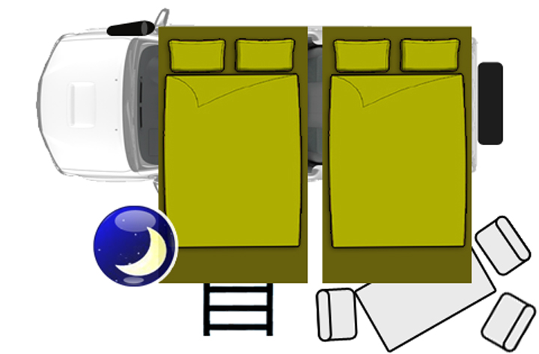

Tent bed: 1400 x 2100 mm
MINIMUM RENTAL DURATION & COSTINGS
Unlimited mileage on rentals of 8 days and longer.
Rentals 7 days and shorter have limited mileage of 220 kilometres per day. Extra kilometres charged at R4 p/km.

Vehicle rentals are calculated on a per calendar day basis, i.e. day of pick-up or drop off is always counted as a full day irrespective of what time it is collected or dropped off. The vehicle must be returned by no later than 4pm on the last day of hire or an extra day could be charged.

OFFICE HOURS:
There are collection branches in Windhoek, Johannesburg and Cape Town. Office Hours are:
Monday to Friday 07:30 – 16:30
Sunday & Public Holidays on request – R 350.00 Surcharge per Contract
All branches are closed 25 December (Christmas Day), 01 January and Easter Sundays.

The latest collection from Windhoek, Namibia is 13:30. Clients arriving on flights after 13:30 will only be able to collect their camper the next day.

ONE-WAY FEE
Between Cape Town and Johannesburg R 5,240.00
Between Windhoek and Cape Town/Johannesburg R5,695.00

TRANSFERS
Charged for collection only. Drop-off to nearest airport is free of charge)
Johannesburg Airport or hotel within 10km from Airport R 140.00 per person
Cape Town Airport or hotel within 10km from Airport R 250.00 per person
Windhoek Airport or hotel within Windhoek R 160.00 per person
Children under 12 years will receive a free Airport Transfer

Please note that the Johannesburg Depot is situated 10 kilometres from the airport, Cape Town Depot 50 kilometres from the airport and Windhoek Depot 22 kilometres from the airport.

VEHICLE COLLECTION/RETURN
Vehicle collection will take approximately 2-3 hours. When returning the vehicle, an hour should be set aside in order for the vehicle / equipment to be checked. All vehicles must be returned with a full fuel tank.

DRIVERS LICENCE AND MINIMUM AGE
A valid non-endorsed international driver’s license together with the national driver’s license is required. Drivers must be 23 years or older for 4x4 vehicles. SA citizens only need to present their valid driver’s license.

PERMITTED AREAS OF TRAVEL FOR THE DISCOVERER DC, FUNX2 AND FUNX4
Vehicles may be taken into South Africa’s neighbouring states, but are not allowed into Angola, Democratic Republic of Congo (DRC), Tanzania or Malawi. A once-off Cross Border Fee of R1,000.00 applies. Please carefully study travel restrictions set out below.

Driving on 4x4 leisure Tracks that require an entrance fee or club membership are also not allowed. All insurance cover is void if vehicles enter these prohibited areas and will result in a breach of contract. The 4x4 is used for driving terrain that is usually inaccessible with a normal two-wheel drive vehicle. Dangerous and irresponsible manoeuvres to test the abilities of the camper to the limit are not allowed under any circumstances as they are dangerous. All towing costs to the nearest depot are for the customer's account.

The supplier reserves the right, at its sole discretion, to restrict vehicle movements in certain areas due to adverse road or weather conditions, political situations or any other reason. Any driving on sand dunes and the Van Zyl's Pass in Namibia is not allowed. Remember that you should never test the abilities of the Discoverer to the fullest, and that you will be liable for the full repair costs if accidents, mechanical damage or roll-overs happen here. Please ensure that the departure, approach and roll angles are observed as in the info manual of the Discoverer. Due to adverse weather circumstances the supplier has the right to restrict road or areas.

Discoverer points:
- Never use 4WD mode on tarred roads as serious damage can occur.
- Drive slowly, especially on gravel and dirt roads. Keep to maximum 60km/h on gravel and 30km/h on soft sand. Try to stay in the existing tyre tracks.
- Keep large following distances on sand/dirt roads to avoid excessive dust which hampers visibility.
- Ensure you brake for drifts in the road. These drifts can appear suddenly and can damage your suspension and more.

Clients are also strongly advised not to drive after sunset.

Camping on the side of the road is not allowed. Camping is only allowed on campsites

CURRENCY FLUCTUATIONS
All credit card transactions are conducted in South African Rand (ZAR). Due to exchange rate fluctuations there could be some variance in the amount refunded compared to the amount initially charged. If a credit card is presented as payment, credit card holder will be jointly and severally liable as a customer. The supplier does not accept American Express and Diners Club cards.

CHANGE OF REQUESTED VEHICLE
The supplier reserves the right to substitute a comparable or superior vehicle should the requested vehicle not be available due to unforeseen circumstances. This shall not constitute a breach of contract and does not entitle the hirer to any refund.

The supplier has 24 hours at its disposal from the time the breakdown has been communicated to solve the problem before lost-time compensation is applicable. In other countries like Namibia (example: Caprivi Strip), Botswana (example: Chobe, Moremi) or inside Zambia, up to 48 hours may be needed.

TRAFFIC OFFENCES
The customer is liable for all traffic offences incurred whilst the vehicle is on hire. Customers will be notified of traffic fines via e-mail. The amount of the fine plus an additional admin fee of R150.00 will be charged to the customers’ credit card. It may take up to three months for traffic fines to reach the suppliers office.

INSURANCE CDW (COLLISSION DAMAGE WAIVER)
Minimum age of driver is 23 years with valid international and national driver’s license. Basic excess is applicable on all vehicles involved in a collision or accident – this is R53,000. This is included in the rental contract. If this option is taken, the hirer is liable for the first R53,000 damage to a vehicle or third party vehicle / property. This excess can be paid by cash or credit card (a manual imprint of the credit card will be taken). The amount will have to be authorised by the bank.

Taking the following options can reduce this excess:
CDW Midi (Medium Cover) is from 3 days onwards. This option reduces the excess to R19,000
CDW Maxi (Super Cover) is from 8 days onwards. This reduces the excess to Nil (see exclusions below)

The hirer will be fully liable for any damage to the vehicle or third party vehicle or property (CDW is cancelled and maximum damage as per quote is payable by the customer) under the following circumstances:

- The terms of the rental contract are breached.
- Damage to the vehicle is caused by careless or reckless driving.
- Any damage or mechanical failure sustained while driving on any 4x4 man-made leisure track specially designed for the purpose of leisure or testing your off-road driving abilities and usually require an entrance fee to make use of and is not part of a public road.
- Damage to the vehicle caused by incorrect use of the clutch, gearbox (using 4x4 mode while driving on tar roads).
- Damages to the drive shafts due to pot holes, drifts or any other obstacle.
- Illegal behaviour, negligence, or a breach of law (e.g. speeding, illegal parking, driving on the wrong side)
- Driving under the influence of drugs or alcohol.
- Driving on restricted roads / areas.
- Water submersion or water damages in engine or in drive shafts are caused.
- Any roll-over damages of any kind – no matter at what speed or how it happened.
- Failure to switch off the engine when dashboard lights indicate a major problem e.g. oil light, radiator water level or temperature gauge.
- Vehicle was driven by person other than permitted driver as per contract.
- All towing costs (when required) to the nearest depot.

CDW terms for Mozambique
You are allowed to drive your 4x4 camper in Mozambique. However, this country is not fully geared for self-drive as yet. This does not mean that self-drive is not possible. For travelling in or through this beautiful country an extra CDW excess is applicable. There is a separate excess of R7,000 or any damage to the vehicle. In the event of the vehicle having to be towed, the customer will arrange to have the vehicle towed to the nearest depot.

The towing costs, as well as any other damages related to the towing of the vehicle, do not form part of this excess and will be for the customer's account.

Roll-over explanation
The Discoverer is higher than a conventional vehicle. This means that the centre of gravity is also at a higher point. This increases the risk of a roll over occurring. A roll-over is defined as a vehicle sustaining all types of damage due to not being in its normal position – on all 4 wheels. Just by lying on its side a vehicle is seen as a rolled-over. Roll-overs that were not caused by a collision are not covered by any CDW insurance. These incidents occur very rarely and should not happen if the driver sticks to the speed limit, scans the road and is fully awake.

TOWING COST
In case of damage to any part of a motorhome it must be assessed if the unit is drivable. If not, the vehicle must be towed to the nearest depot by a reputable towing company authorized by the supplier. Towing and recovery costs arising due to any type of accident is to be paid by the customer irrespective of the CDW (Insurance) option.

ACCIDENTS
All accidents must be reported to the supplier and the local Police within 24 hours. Failing to report accidents voids all insurance cover and the hirer becomes fully liable for all costs. The hirer is responsible for the full recovery (e.g. towing) of the damaged vehicle to the original rental depot.

EQUIPMENT
Refrigerators, stoves, air conditioners, etc. are checked by the owner and the client before every rental, consequently the supplier does not accept liability for any possible malfunction of these units during the rental period.

GAUTENG ROAD TAXES
A Levy of R 500.00 is raised on all rentals departing and/or returning at the Johannesburg depot. When the E-Toll statement arrives at the offices, charges will be deducted for the incurred fees plus an admin fee. The remaining amount will be refunded to the renter. All manned toll-booths throughout South Africa need to be paid on the spot by the client.

CO2 TAXES NAMIBIA
For rentals collecting or returning in Namibia a CO2 tax of R 450.00 (once off) will be charged. This amount is payable upon collection of the vehicle and is excluded from the quotation.

CANCELLATION FEES
3 Months before departure date: 10% of total costs
2 Months before departure date: 25 % of total costs
1 Month before departure date: 50 % of total costs
1 Week or No-show: 100 % of total costs
If vehicle is returned early or collected late – No Refund Available

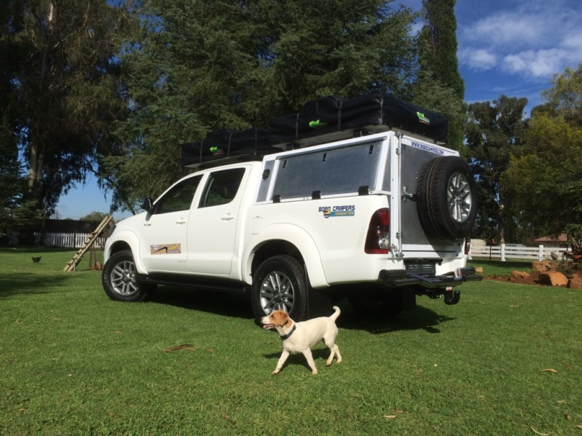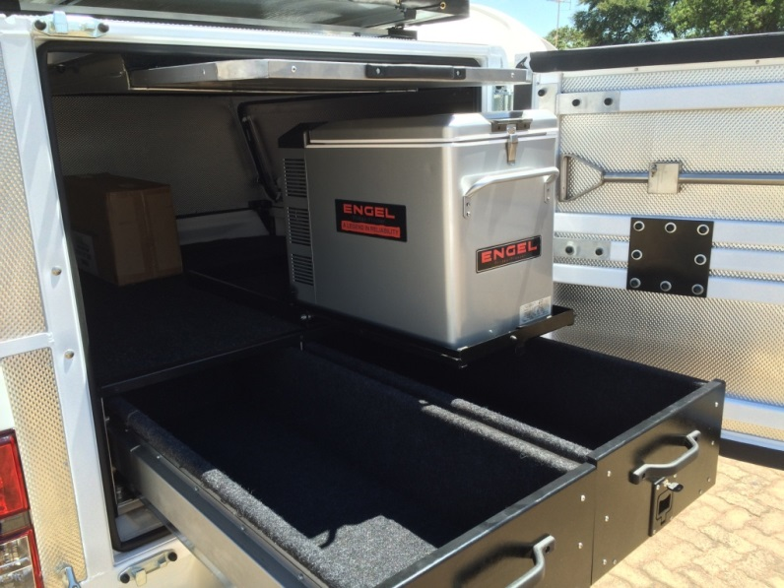

TRAVELLING TO SOUTH AFRICA WITH CHILDREN – NEW VISA REGULATION
Effective 01 June 2015 New regulations for children travelling to & from South Africa.

Effective travel date from 01 June 2015, regardless of the time of booking, all minors under 18 years of age travelling to and from the Republic of South Africa, have to present additional documents which were not needed until now. These new regulations apply to all travellers, regardless of their nationality. They were promulgated (set out) in terms of the South African Immigration Amendment Act of 2010 and define children as persons under the age of 18.

It is the responsibility of passengers to ensure their children have the correct documentation or risk being denied boarding. The new law will be enforced by airlines and immigration officials across the board (land, sea and air).

REQUIRED DOCUMENTATION:
- When both parents are travelling with a child, they need to produce an unabridged birth certificate that shows the names of both parents. In cases where the certificate is in a language other than English, it must be accompanied by a sworn translation issued by a competent authority in the country concerned.
- When a child travels with only one parent, additional documents should include an affidavit in which the absent parent gives consent for the child to travel, a court order granting full parental responsibilities or legal guardianship of the child, or the death certificate of the absent parent. The affidavit should be no more than three months old, from date of travel.
- In the case of a child travelling with a person other than a parent, the unabridged birth certificate must be supplemented by affidavits from the parents or legal guardians confirming that the child may travel with that person, copies of the identity documents or passports of the parents or legal guardian, and the contact details of the parents or legal guardian.
- Similarly, a child travelling as an unaccompanied minor would have to produce the unabridged birth certificate, proof of consent from both parents, or legal guardian and contact details, plus documentation relating to the person receiving the child in the Republic. The latter documentation should include a letter stating the person’s contact details and residential address and contact details where the child will be residing, plus a copy of his or her identity document, passport or residence permit.

All documents must either be original or certified as true copies of the original, by a competent authority. Documents not in English must be accompanied by a sworn translation. For more information
http://www.dha.gov.za/files/Brochures/Immigrationleaflet.pdf

