Product Description
Based on the Iveco 35S14 chassis, this roomy and luxurious camper sleeps 4 adults and will ensure that your holiday is as comfortable as it can be.

- 5 Speed Manual Transmission
- Automatic Gearbox also available (on request – R75.00 surcharge per day applies)
- 2.3L Turbo inter-cooled Diesel Engine
- Fuel Consumption 12l/100km
- 70L Fuel Tank (Diesel)
- Number of Seat Belts in Driver Cab – 2
- Number of Seat Belts in Living Area – 2
- Maximum Occupants in Total - 4
- Air-Conditioning in Cabin
- 220V Air-Conditioning in Living Unit
- Radio/CD & MP3 Capability
- 60L Fresh Water Tank
- 220V Gas Hot Water System
- 80L built-in Fridge/Freezer
- Chemical Cassette Toilet with separate wash basin
- Hand-held Shower
- Microwave
- Two-plate Gas Stove
- 5kg Gas Bottle Capacity
- Roof Ventilator
- Kitchen Utensils
- Camping Table & Chairs
- Cutlery
- Stainless Steel Crockery
- Bedding & Towels
- Built-in (lockable) Safe
- Road Maps
DISCOVERER 4 DAY PLAN
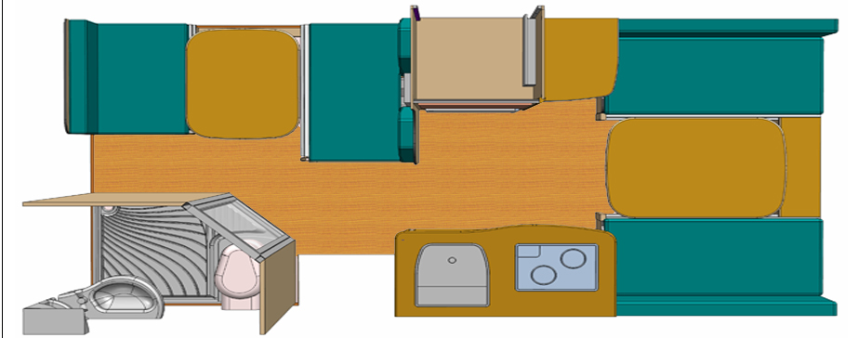

DISCOVERER 4 NIGHT PLAN
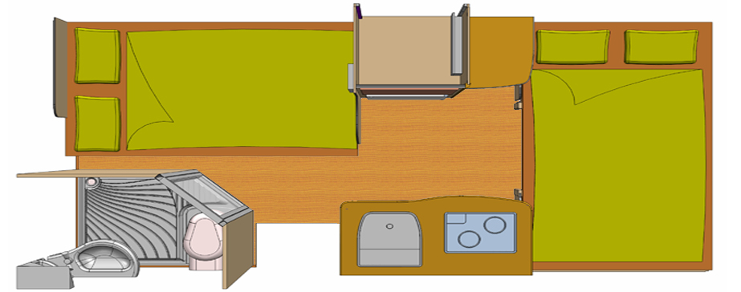
BED DIMENSIONS
Main bed 1 1250 x 1900 mm
Bed 2 1200 x 2000 mm

MINIMUM RENTAL DURATION & COSTINGS
Unlimited mileage on rentals of 8 days and longer.
Rentals 7 days and shorter have limited mileage of 220 kilometres per day. Extra kilometres charged at R4 p/km.

Vehicle rentals are calculated on a per calendar day basis, i.e. day of pick-up or drop off is always counted as a full day irrespective of what time it is collected or dropped off. The vehicle must be returned by no later than 4pm on the last day of hire or an extra day could be charged.

OFFICE HOURS:
There are collection branches in Windhoek, Johannesburg and Cape Town. Office Hours are:
Monday to Friday 07:30 – 16:30
Sunday & Public Holidays on request – R 350.00 Surcharge per Contract
All branches are closed 25 December (Christmas Day), 01 January and Easter Sundays.

The latest collection in Windhoek Namibia is 13:30, clients arriving on flights after 13:30 will only be able to collect their camper the next day.

ONE-WAY FEE
Between Cape Town and Johannesburg R 5,240.00
Between Windhoek and Cape Town/Johannesburg R 5,695.00

TRANSFERS
Charged for collection only. Drop-off to nearest airport is free of charge)
Johannesburg Airport or hotel within 10km from Airport R 140.00 per person
Cape Town Airport or hotel within 10km from Airport R 250.00 per person
Windhoek Airport or hotel within Windhoek R 160.00 per person
Children under 12 years will receive a free Airport Transfer

Please note that the Johannesburg Depot is situated 10 kilometres from the airport, Cape Town Depot 50 kilometres from the airport and the Windhoek Depot 22 kilometres from the airport.

VEHICLE COLLECTION/RETURN
Vehicle collection will take approximately 2-3 hours. When returning the vehicle, an hour should be set aside in order for the vehicle / equipment to be checked. All vehicles must be returned with a full fuel tank.

DRIVERS LICENCE AND MINIMUM AGE
A valid non-endorsed international driver’s license together with the national driver’s license is required. Drivers must be 21 years or older (23 years of age is applicable for 4x4 vehicles). SA citizens only need to present their valid driver’s license.

PROHIBITED AREAS OF TRAVEL/CROSS BORDER FOR DISCOVERER 4,6 AND FUN MODELS
Cross Border Rentals are allowed to South Africa, Namibia, Botswana, Zambia and Swaziland. A once-off Cross Border Fee of R1,000.00 applies. Please carefully study travel restrictions set out below.

All campers are allowed to travel on any properly tarred surface. Good smooth sand roads (non-corrugated) are also permitted. There are areas however that are not suitable for driving with a camper. These are: the Swartberg Pass (SA), the Sani Pass (SA), Kalahari Gemsbok Park (also called Kgalagadi Transfrontier Park), The road to the Sentech Towers in Marakele Park (SA), Baviaanskloof Pass (SA), all of Mozambique, all of Malawi, all of Angola, Zambia further than Livingstone, all 4x4 trails, the Skeleton Coast Park (Namibia), the short road from Hobas to the Viewpoint (Fish River Canyon), Van Zyl's Pass (Namibia), any sand dune, Sandwich Harbour (Namibia), the entire Kaokoland (Namibia), the Okavango Delta (Botswana) the Makgadigadi Pans (Botswana), narrow and steep single lane mountain passes and any road in South Africa, Swaziland, Lesotho, Botswana and Namibia that do not adhere to the condition of roads as mentioned above. D, G or F marked roads in Namibia(e.g. D4130 etc). Travelling in Zimbabwe is not allowed, since items like fuel or food are currently not always available. The supplier does not take responsibility for ANY damages or claims arising out of fast speeds and/or long distance driving on the washboard roads (especially Croads) in Namibia. These include all air conditioners, radiators, tyres and suspension systems. Due to weather circumstances the supplier has the right to restrict road or areas.

Clients are also strongly advised not to drive after sunset.

Camping on the side of the road is not allowed. Camping is only allowed on campsites

CURRENCY FLUCTUATIONS
All credit card transactions are conducted in South African Rand (ZAR). Due to exchange rate fluctuations there could be some variance in the amount refunded compared to the amount initially charged. If a credit card is presented as payment, credit card holder will be jointly and severally liable as a customer. The supplier does not accept American Express and Diners Club and Debit cards.

CHANGE OF REQUESTED VEHICLE
The supplier reserves the right to substitute, under special circumstances, the desired vehicle with an equal or better vehicle without prior notice before the start of any rental period.

If a vehicle needs to be substituted because of an accident or mechanical problems, and the renter refused to accept this replacement vehicle as stipulated above, the hirer is seen to terminate the contract, an no reimbursements will apply.

a comparable or superior vehicle should the requested vehicle not be available due to unforeseen circumstances. This shall not constitute a breach of contract and does not entitle the hirer to any refund.

TELEPHONE COSTS
Clients will not be reimbursed for costs incurred through telephone call to the supplier offices or staff. Renters are advised to purchase a local SIM car instead. The costs for local calls are usually much cheaper.

TRAFFIC OFFENCES
The customer is liable for all traffic offences incurred whilst the vehicle is on hire. Customers will be notified of traffic fines via e-mail. The amount of the fine plus an additional admin fee of R150.00 will be charged to the customers’ credit card. It may take up to three months for traffic fines to reach the suppliers office.

INSURANCE CDW (COLLISSION DAMAGE WAIVER)
Minimum age of driver is 21 years with valid international and national drivers license. Basic excess is applicable on all vehicles involved in a collision or accident – this is R 53,000. This is included in the rental contract. If this option is taken, the hirer is liable for the first R 53,000 damage to a vehicle or third party vehicle / property. This excess can be paid by cash or credit card (a manual imprint of the credit card will be taken). The amount will have to be authorised by the bank.

Taking the following options can reduce this excess:
CDW Midi (Medium Cover) is from 3 days onwards. This option reduces the excess to R19,000
CDW Maxi (Super Cover) is from 8 days onwards. This reduces the excess to Nil (see exclusions below)

The hirer is responsible for the following damages under any circumstances with no CDW waiver applicable:
- Engine damages due to negligence or abuse (e.g. failed to respond to dashboard warning lights)
- Clutch failure due to driver abuse (e.g. burnt pressure plate due to excessive slipping, shredded clutch plate).
- Any water damages due to water entering the engine or drive shafts.
- Roll-over damages of any kind without exception – including speed, loss of control etc.
- Illegal behaviour, negligence, or a breach of law (e.g. speeding, illegal parking, driving on the wrong side)
- Driving under the influence of drugs or alcohol
- Driving on restricted roads / areas
- Vehicle was driven by person other than permitted driver as stipulated in the contract.
- Towing costs, if required, for all above damages.
Roll-over explanation
A roll-over is defined as a vehicle sustaining all types of damage due to not being in its normal position – on all 4 wheels. Just by lying on its side a vehicle is seen as a rolled-over. Roll-overs that were not caused by a collision are not covered by any CDW insurance. These incidents occur very rarely and should not happen if the driver sticks to the speed limit, scans the road and is awake.

TOWING COST
In case of damage to any part of a motorhome it must be assessed if the unit is drivable. If not, the vehicle must be towed to the nearest depot by a reputable towing company authorized by the supplier. Towing and recovery costs arising due to any type of accident is to be paid by the customer irrespective of the CDW (Insurance) option.

ACCIDENTS
All accidents must be reported to the supplier and the local Police within 24 hours. Failing to report accidents voids all insurance cover and the hirer becomes fully liable for all costs. The hirer is responsible for the full recovery (e.g. towing) of the damaged vehicle to the original rental depot.

EQUIPMENT
Refrigerators, stoves, air conditioners and microwave are checked by the owner and the client before every rental, consequently the supplier does not accept liability for any possible malfunction of these units during the rental period.

GAUTENG ROAD TAXES
A Levy of R 800.00 is raised on all rentals departing and/or returning at the Johannesburg depot. When the E-Toll statement arrives at the offices, charges will be deducted for the incurred fees plus an admin fee. The remaining amount will be refunded to the renter. All manned toll-booths throughout South Africa need to be paid on the spot by the client.

CANCELLATION FEES
3 Months before departure date: 10% of total costs
2 Months before departure date: 25 % of total costs
1 Month before departure date: 50 % of total costs
1 Week or No-show: 100 % of total costs
If vehicle is returned early or collected late – No Refund Available
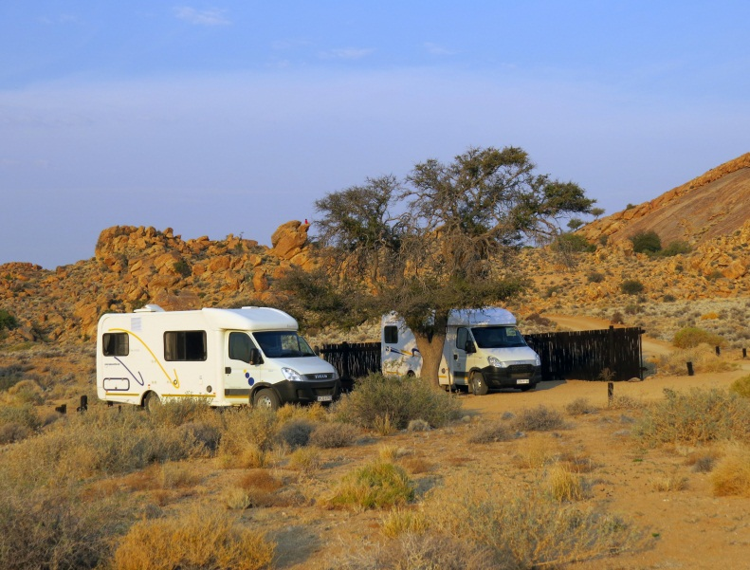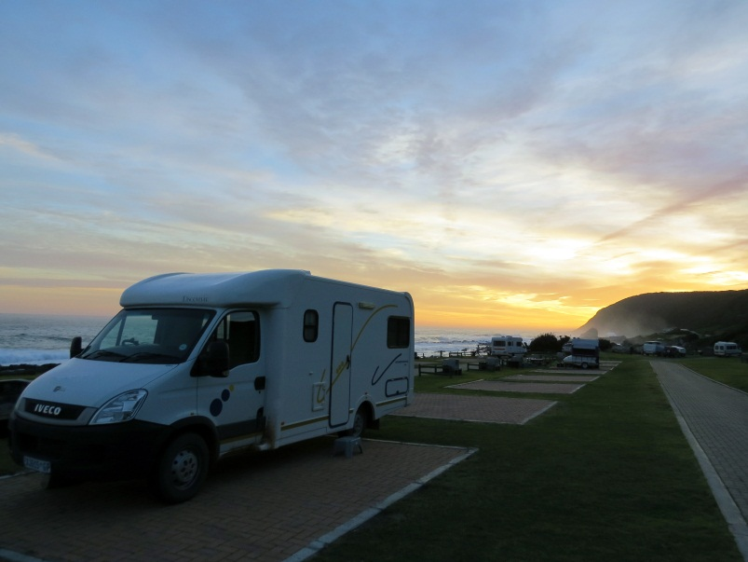

TRAVELLING TO SOUTH AFRICA WITH CHILDREN – NEW VISA REGULATION
Effective 01 June 2015 New regulations for children travelling to & from South Africa.

Effective travel date from 01 June 2015, regardless of the time of booking, all minors under 18 years of age travelling to and from the Republic of South Africa, have to present additional documents which were not needed until now. These new regulations apply to all travellers, regardless of their nationality. They were promulgated (set out) in terms of the South African Immigration Amendment Act of 2010 and define children as persons under the age of 18.

It is the responsibility of passengers to ensure their children have the correct documentation or risk being denied boarding. The new law will be enforced by airlines and immigration officials across the board (land, sea and air).

REQUIRED DOCUMENTATION:
- When both parents are travelling with a child, they need to produce an unabridged birth certificate that shows the names of both parents. In cases where the certificate is in a language other than English, it must be accompanied by a sworn translation issued by a competent authority in the country concerned.
- When a child travels with only one parent, additional documents should include an affidavit in which the absent parent gives consent for the child to travel, a court order granting full parental responsibilities or legal guardianship of the child, or the death certificate of the absent parent. The affidavit should be no more than three months old, from date of travel.
- In the case of a child travelling with a person other than a parent, the unabridged birth certificate must be supplemented by affidavits from the parents or legal guardians confirming that the child may travel with that person, copies of the identity documents or passports of the parents or legal guardian, and the contact details of the parents or legal guardian.
- Similarly, a child travelling as an unaccompanied minor would have to produce the unabridged birth certificate, proof of consent from both parents, or legal guardian and contact details, plus documentation relating to the person receiving the child in the Republic. The latter documentation should include a letter stating the person’s contact details and residential address and contact details where the child will be residing, plus a copy of his or her identity document, passport or residence permit.

All documents must either be original or certified as true copies of the original, by a competent authority. Documents not in English must be accompanied by a sworn translation. For more information
http://www.dha.gov.za/files/Brochures/Immigrationleaflet.pdf

